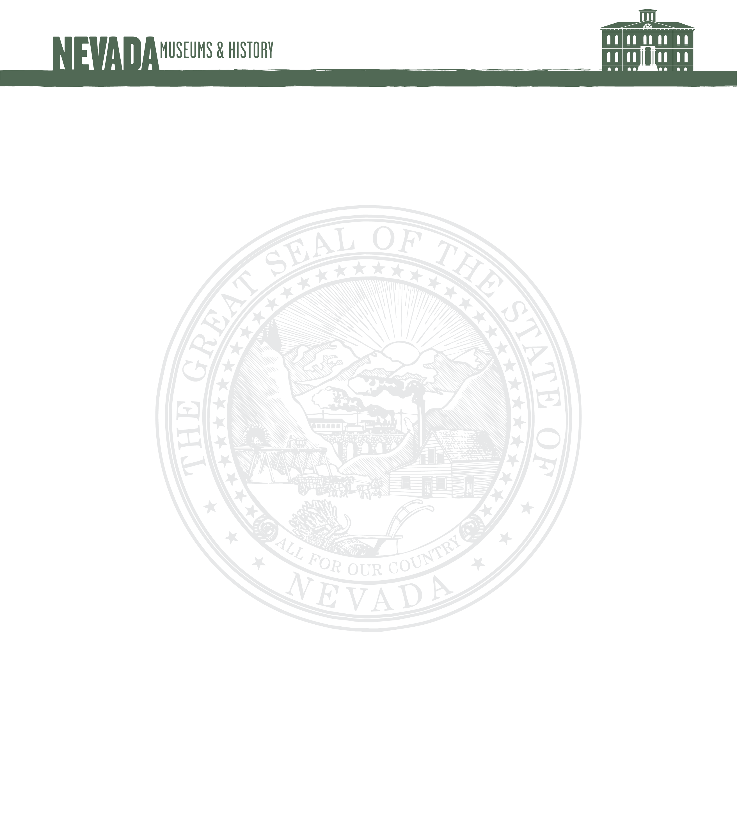

REPORT TO THE
BOARD OF MUSEUMS AND HISTORY
JUNE 11-12, 2020

I. Private Funds Budget Summary
Revenue/Expenditure Comparison Narrative:
The above figures reflect the third quarter of fiscal year 2020 revenues and expenditures as of March 31, 2020
* Further detail available in the below identified sections.

II. Museum Store Sales

NSRM CC STORE SALES ANNUAL COMPARISON

Museum Store Sales Narrative: Due to decreased visitation over the winter months, the Museum Store’s sales dropped, as expected, during the month of January, but were strong in February, even though visitation did not have an increase that month, nor did the museum host any special events. Lara contributes this partly to having the store well-stocked, but also the City of Carson City reported an increase of 19% in sales tax for the month of February, so local retailers had a good month overall. Even with the usual drop in winter sales, the store showed a strong average sale per visitor at $5.90 and the average sale per customer was $22.12. March was starting on the positive side with an average sale per visitor at $6.70, but unfortunately the museum and store were shut down on March 16, in response to the Covid 19 pandemic. Report is through March 31, 2020.

III. Museum Store Revenue and Expenditure Chart

Museum Store Revenue and Expenditure Chart Narrative: Museum store revenues took the expected downturn in January, but sales were surprisingly good in February. Purchasing increased in January because the store inventory was depleted after Santa Train, and Lara wanted to have enough items in stock to get through the winter months. Lara found a new vendor and ordered “Magic T-shirts” that have a black and white design that bursts into color in the sun. She ordered children & infant tees and tote bags that feature train and Nevada designs with our museum and Carson City name drops, this was the $495 expenditure in February. The order was received at the beginning of March in anticipation of the busy spring season. Purchasing was going to resume heavily at the end of March, but the museum and store were shut down on March 16, in response to the Covid 19 pandemic. Report is through March 31, 2020.
IV. Membership Program
Membership Program Narrative:
The Nevada State Railroad Museum does not have a membership program. People wishing to support the museum through membership join the Friends of the Nevada State Railroad Museum. This non-profit organization provides cash support for various museum projects and programs. As of this date, the current total of memberships stands at 553. The Museum and Friends are establishing a memorandum of understanding to formally codify the 30-year relationship. Report is through March 31, 2020.

V. Museum Attendance Figures
Museum Attendance Figures Narrative: The Museum was experiencing a sustained increase in visitation due to added activities (night photo shoots) up until the Covid 19 Pandemic closure on March 15, 2020. We are making effort to continues to reach visitor via Social media and hope for increased visitation when we open. Report is through March 31, 2020.
VI. Attendance Receipts
Museum Attendance Receipts Narrative: Attendance receipts have increased in FY 20. February was a particularly tremendous month. The Museum hosted a night photo shoot with Pete Lerro Productions that brought nearly 30 people from all over the globe to Nevada to have the rare opportunity to shoot photos of equipment in the dark. This brought a much-needed boost to visitation at NSRM. March 31, 2020.

VII. Train Ride Receipts
Train Ride Receipts Narrative: Train operations ended in December after Santa Train. Expected school tours in March were cancelled due to COVID-19 concerns. Report is through March 31, 2020.

VIII. Fundraising Activities:

- In December, the museum received a donation of $106,000 in memory of longtime Carson City resident Francis M. Parker. We are thankful to the Francis M. Parker for her generous donation.

- The museum and the Friends of the NSRM are preparing an aggressive fundraising campaign for the repair of a locomotive for use in annual operations. It is critical that the museum decreases its reliance on artifacts for use in general passenger traffic.

- The museum is offering itself as a destination location for weddings and receptions.

- The museum is in discussions with several families who are considering the museum in their estate planning.

IX. General Museum Activities

- NSRM has hired employees to fill two new part-time Museum Attendant I positions. Jilliene Jaeger and Stephanie Fry are the new Museum Attendant I’s and they started on Monday, January 6.

- The Museum hired a new custodian on March 9. Stephen Davis is the new custodian at the museum. Stephen comes to the museum from the Legislative Counsel Bureau where he was custodian for several years. Stephen has hit the ground running and has made a significant impact already.

- With the hiring of additional staff, the museum shifted to six-day per week operations. Starting on February 19, the museum opened Wednesdays from 9:00am to 4:30pm.

- On February 10, the museum hosted an all-day photo shoot with Lerro Productions. The photo shoot included the Inyo, the Dayton, the Glenbrook, No. 25, the McKeen Motor Car, and volunteers in period costume. Thirty photographers from around the world participated in the event. The event was well-organized and went off without any major issues. Thanks to the museum’s staff and volunteers for putting on a great show for Lerro Productions.

- The Museum is working with the Nevada Women’s History Project to celebrate the Centennial of the Women’s Suffrage movement in Nevada. The Museum was able to find physical evidence of the ‘Suffrage Special’ on Coach 17. We are planning to recreate this event on August 15th, 2020.

- NSRM received a generous donation of March 2. Stan Gentry of Clear Lake, Iowa, donated his replica locomotive of the first V&T locomotive, the Lyon. Mr. Gentry spent about 30 years trying to recreate the Lyon before donating the locomotive to the museum. The museum will conduct restoration feasibility study to determine how to proceed with the Lyon project going forward.

- In response to the COVID-19 pandemic, the Nevada State Railroad Museum has been closed since March 15.

- The museum has completed an audio tour for the Transcontinental Railroad exhibit. There are two ways to listen to it. One is to download the Nevada State Museums app on your mobile phone. You can find it by searching “Nevada State Museums” in the Apple App Store or on your Android device. Then, you can click on “Nevada State Railroad Museum, Carson City” and then “Audio Tours” to find the audio tours there. Another option is to go to this website: https://nevadastatemuseums.oncell.com.

Mission Statement

The Nevada State Railroad Museum is a cultural resource dedicated to educating the broadest possible audience about the contributions of railroads and railroading to the development of Nevada.

This mission is realized through the collection, preservation and interpretation of significant locomotives, rolling stock, artifacts, photographs, documents and ephemera directly relating to railroads and railroading in Nevada.

Current Operations

As of February 1, 2020, the museum expanded to operating for the public six days per week; Wednesday through Monday, 9:00 a.m.to 4:30 p.m.

